**Task No. 1:** Write a short note on Banker’s algorithm stating its main purpose and working mechanism.

**Solution:**

The Banker's algorithm is a resource allocation and deadlock avoidance algorithm developed by Edsger Dijkstra. It is used to ensure that a system will not enter a deadlock state. The algorithm works by first calculating the maximum number of resources that each process can use. It then calculates the number of resources that are currently available. Finally, it checks if the system is in a safe state. If the system is in a safe state, then the algorithm will allow the processes to continue using resources. If the system is not in a safe state, then the algorithm will block the processes from using resources.

The main purpose of the Banker's algorithm is to prevent deadlocks. A deadlock occurs when a process is waiting for a resource that is being held by another process, which is in turn waiting for a resource that is being held by the first process. The Banker's algorithm prevents deadlocks by ensuring that no process can hold more resources than it needs.

The Banker's algorithm works by first calculating the maximum amount of resources that each process can use. This is done by creating a matrix where each row represents a process and each column represents a resource. The values in the matrix represent the maximum amount of each resource that each process can use.

Once the maximum resource usage has been calculated, the algorithm calculates the amount of resources that are currently available. This is done by creating a vector where each element represents the number of resources of a particular type that are currently available.

Finally, the algorithm checks if the system is in a safe state. To do this, it uses a recursive algorithm that works as follows:

1. For each process, check if the process can finish without causing a deadlock. If the process can finish, then mark the process as finished and remove the resources that the process is using from the available resources vector.
2. If all processes have been marked as finished, then the system is in a safe state.
3. If not all processes have been marked as finished, then go back to step 1.

If the system is not in a safe state, then the algorithm will block the processes from using resources. The algorithm will continue to block the processes until the system enters a safe state.

**Task No. 2:** Implement the Banker’s Algorithm explained above in C language.

**Solution:**

#include <stdio.h>

#define MAX_RESOURCES 10

#define MAX_PROCESSES 10

// Function to check if the requested resources are less than or equal to the available resources

int checkSafe(int need[][MAX_RESOURCES], int available[], int n, int m, int allocated[][MAX_RESOURCES]) {

int work[MAX_RESOURCES], finish[MAX_PROCESSES] = {0};

int i, j, k;

// Initializing work array with available resources

for (i = 0; i < m; i++)

work[i] = available[i];

// Checking if each process can complete or not

for (i = 0; i < n; i++) {

if (finish[i] == 0) {

int canAllocate = 1;

for (j = 0; j < m; j++) {

if (need[i][j] > work[j]) {

canAllocate = 0;

break;

}

}

if (canAllocate) {

// Allocating resources to the current process

for (k = 0; k < m; k++)

work[k] += allocated[i][k];

finish[i] = 1;

i = -1; // Start checking from the beginning as resources might be released

}

}

}

// Checking if all processes are finished or not

for (i = 0; i < n; i++) {

if (finish[i] == 0)

return 0; // Not safe

}

return 1; // Safe state

}

int main() {

int available[MAX_RESOURCES], allocated[MAX_PROCESSES][MAX_RESOURCES], need[MAX_PROCESSES][MAX_RESOURCES];

int n, m; // n = number of processes, m = number of resources

printf("Enter the number of processes: ");

scanf("%d", &n);

printf("Enter the number of resources: ");

scanf("%d", &m);

printf("Enter the available resources: ");

for (int i = 0; i < m; i++)

scanf("%d", &available[i]);

printf("Enter the allocated resources for each process:\n");

for (int i = 0; i < n; i++) {

printf("Process %d: ", i + 1);

for (int j = 0; j < m; j++)

scanf("%d", &allocated[i][j]);

}

printf("Enter the maximum resources needed for each process:\n");

for (int i = 0; i < n; i++) {

printf("Process %d: ", i + 1);

for (int j = 0; j < m; j++)

scanf("%d", &need[i][j]);

}

if (checkSafe(need, available, n, m, allocated))

printf("Safe state: Resources can be allocated to all processes.\n");

else

printf("Unsafe state: Resources cannot be allocated to all processes.\n");

return 0;

}

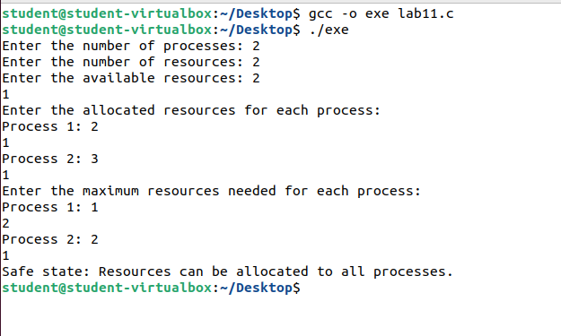**Output:**

